Retiring Old Glory
When the United States flag (Old Glory) becomes worn, torn, faded or badly soiled, it is time to replace it with a new flag, and the old flag should be "retired" with all the dignity and respect befitting our nation's flag. The traditional method of retirement is to incinerate the flag, but this does not mean that one should simply drop the entire flag (intact) into a fire.
A flag ceases to be a flag when it is cut into pieces. In addition, it is easier to completely incinerate the flag, if it is cut into smaller pieces. A flag should never be torn up like an old bed sheet. It should be cut up with scissors or shears in a methodical manner. The corners of the flag should be stretched out over a table top and someone should cut the flag in half, vertically (be careful not to cut up the blue star field (see the figure). Then, place the two halves together and cut them in half, horizontally. You will end up with four pieces of flag, one being the blue star field.
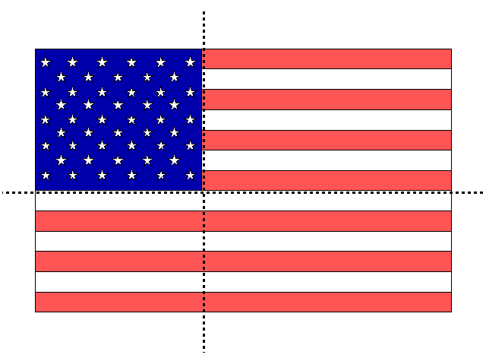
NOTE: The reason we do not cut the blue star field is it represents the union of the fifty states and one should never let the union be broken.
While the Scouts are performing the flag dissection, other Scouts should start and tend a medium size, wood fire (preferably in a metal drum or incinerator). Once the flag remnants and fire are ready, you perform the following ceremony. The Scouts maintain a vigil over the fire until all traces of the flag remnants are destroyed. Then, the fire is extinguished and the ashes are buried. The burial can be completed with a moment of silence while taps is played by a bugler.
NOTE: Before accepting a flag for retirement, the recipient should obtain information about its history. For example: Where has it flown? How long? Any memorable events happen at that site? This information should be used in the ceremony.
Flag Retirement Ceremony
Person(s) ----- Text or Action

Adult Leader: The U.S. flag is more than just some brightly colored cloth.. it is a symbol of our nation.

Scout #1: Seven red stripes and six white strips; together they represent the original 13 colonies that gained us liberty.

Scout #2: The red stripes remind us of the lifeblood of brave men and women who were ready to die for this, their country.

Scout #3: The white stripes remind us of purity and cleanliness of purpose, thought, word and deed.

Scout #4: The blue is for truth and justice, like the eternal blue of the star-filled heavens.

Scout #5: The stars represent the fifty sovereign states of our union.

Adult Leader or SPL: The U.S. flag should be treated with respect when it's flying, and it should be treated with respect when it's being retired.

Scout #6: The American Creed states, "it is my duty to my country to love it, to respect its Constitution, to obey its laws, to respect its flag, and to defend it against all enemies."

Scout #7: Therefore, we retire flags with dignity and respect when they become worn, torn, faded, or badly soiled.

Adult Leader or SPL: This flag is ready to be retired. Its history is as follows:
First Raised (when):
At (location):
Memorable event or fact:

Scout #8: A flag ceases to be a flag when it is cut into pieces. We cut the flag into four pieces: three red and white striped banners and the blue star field. We leave the blue field intact because no one should ever let the union be broken.

Adult Leader or SPL: As the parts of the flag are placed in the fire remember.. Old Flags never die, they just get fired up!
The Scouts will maintain a vigil over the fire until no traces of the flag remnants remain. Then the ashes will be collected and buried.
This concludes this ceremony. Thank you for attending.

